Bash Scripting

Output to Screen

I have created a directory named /shahbaz/scripts to store all my scripts. Then I have checked pwd, opened helloworld.bash with vi and added the script. After that I gave chmod 755 permissions and executed using ./helloworld.bash, finally used cat command to view the script.

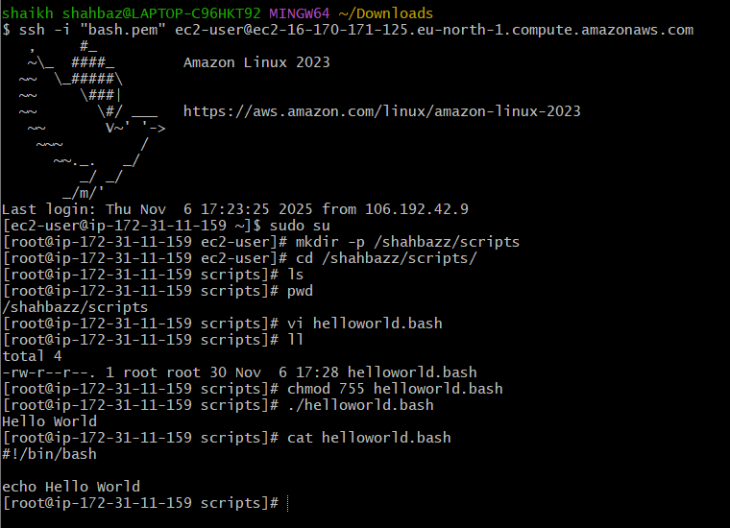

1. Defining commands
Add comments and commands.
#!/bin/bash
pwd
ls
whoami
date
cal
touch a b c

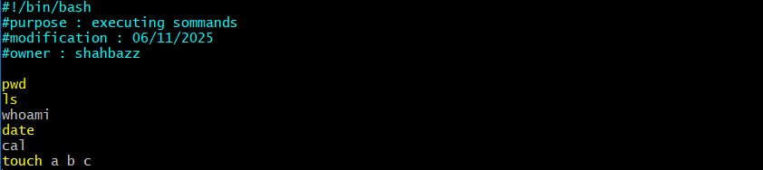

chmod 755 for allow permissions to file

For running bash commands we use

./commands.bash
Bash commands.bash (runs file without permissions)

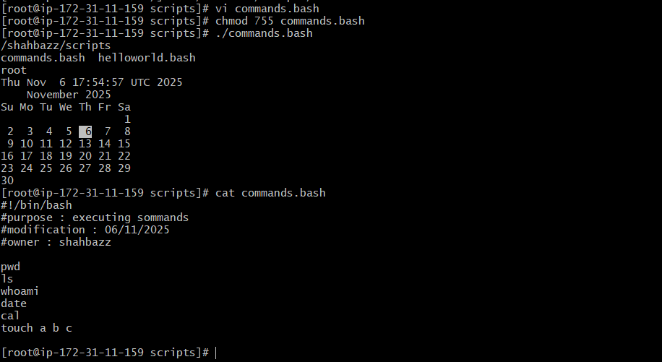

2. Admin script
Steps:
I am in /shahbaz/scripts directory
vi admin.bash
#!/bin/bash
#purpose : admin tasks
#modification : 06/11/2025
#owner : shahabzz
Top | head -10
df -h
free -m
uptime
iostat

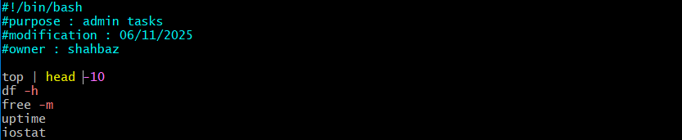

After that chmod 755 admin.bash to allow read and execute permissions
Then ./admin.bash to run the script
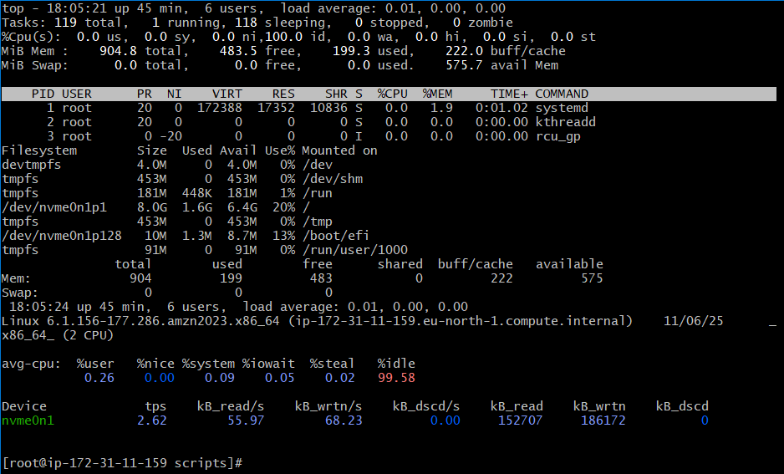
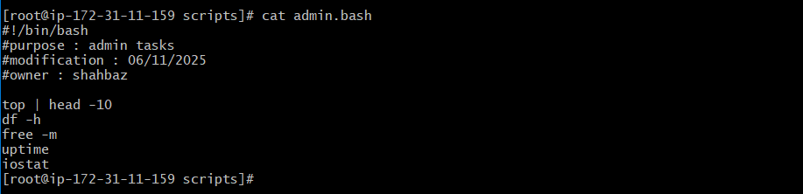

3. Defining variables.
Steps:
I am in /shahbaz/scripts directory
vi variables.bash
#!/bin/bash
#Define Variables
p=pwd
l=ls
wi=whoami
d=date
c='cal 2025'

echo Run Variables Tasks
echo
$p
$l
$wi
$d
$c
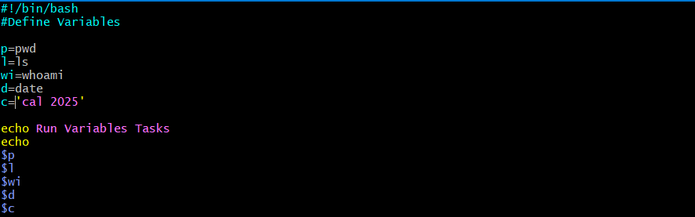

After that chmod 755 variables.bash to allow read and execute permissions
Then ./variables.bash to run the script

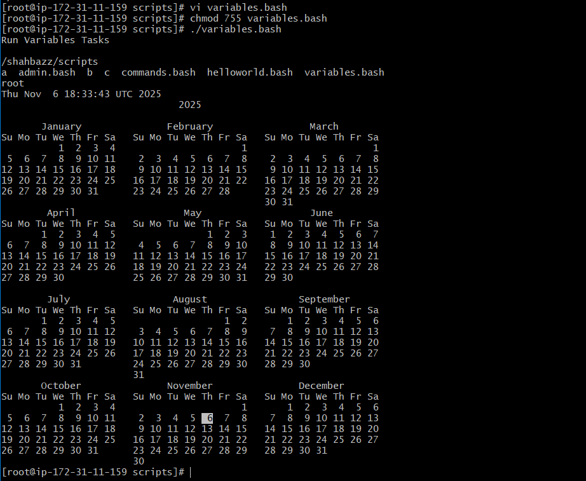
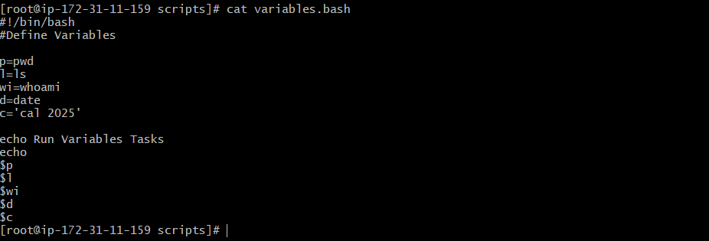

4. Input/Output scripts.

Input script.
Read -- To take command from user
Echo – To print the output
Steps:
I am in /shahbaz/scripts directory
vi input.bash
# #!/bin/bash
echo Hello, my name is shahbazz
echo
echo what is your name?
read name
echo
echo Hello $name
echo

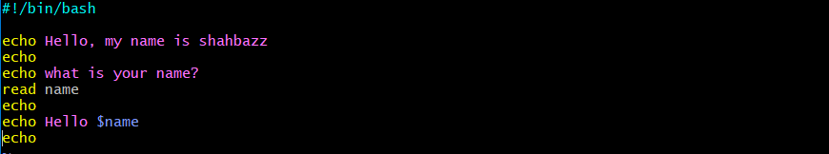

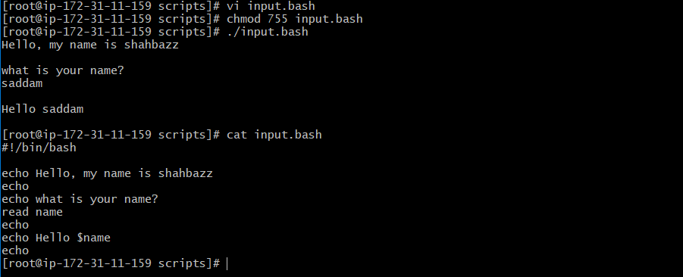

5. Display Hostname
Output script.
Read -- To take command from user
Echo – To print the output
Steps:
I am in /shahbaz/scripts directory
vi output.bash
#we need to use the ticks if you want to use this in echo or else not required
#!/bin/bash
a=`hostname`
echo Hello, my name is $a
echo
echo what is your name?
read b
echo
echo Hello $b
echo
